CS 255 System Design Document Template

This template lays out all the different sections that you need to complete for Project Two. Each section has guidance to prompt your thinking. You will need to continually reference the interview transcript as you work to make sure that you are addressing your client’s needs. There is no required length for the final document. Instead the goal is to complete each section based on what your client’s needs are. Remove this note when you are finished, and replace all bracketed text with the relevant information.

UML Diagrams

UML Use Case Diagram
Below are use case diagrams from the perspectives of the student, instructor, and administrator.
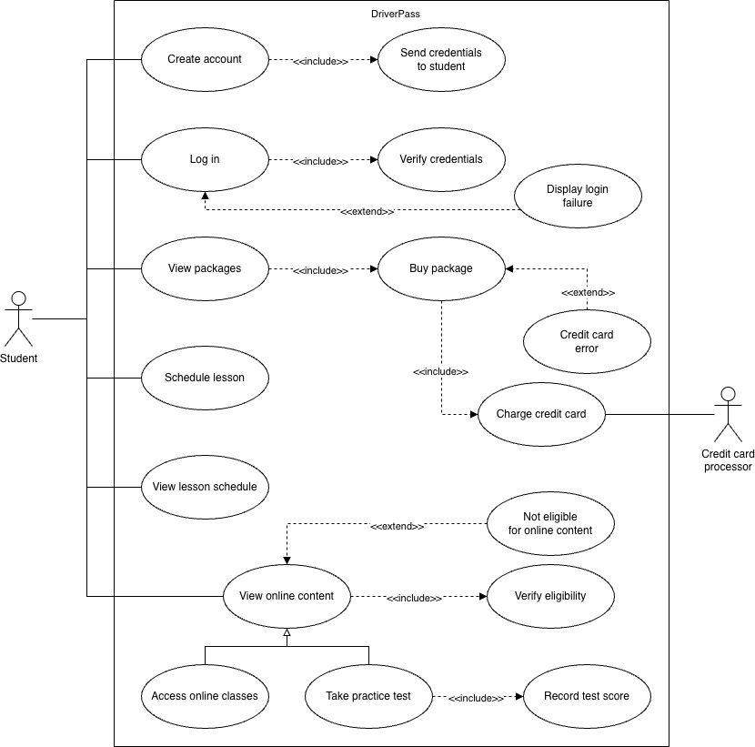
Figure 1. UML use case diagram from student's perspective.
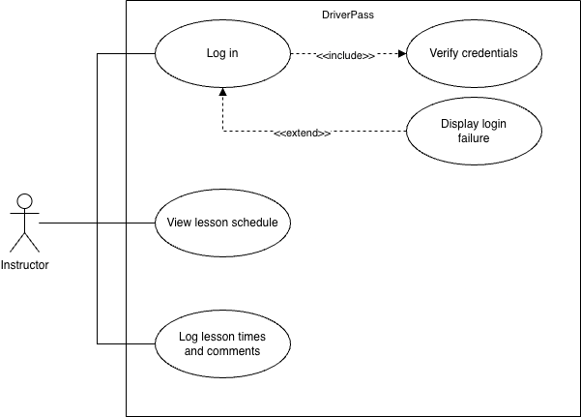
Figure 2. UML use case diagram from the instructor's perspective.
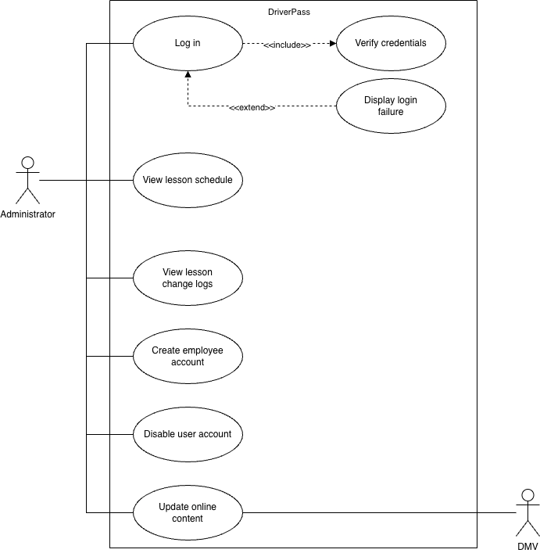
Figure 3. UML use case diagram from the administrator's perspective.

UML Activity Diagrams
Below are activity diagrams for the use case in which the student selects and buys an instruction package and the use case in which the student takes a practice test.
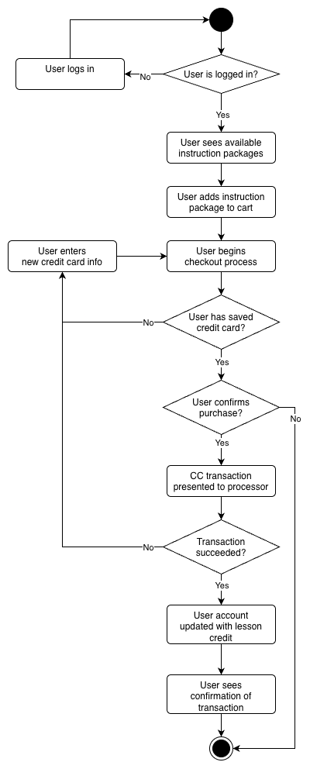
Figure 4. UML activity diagram for purchasing instruction package.
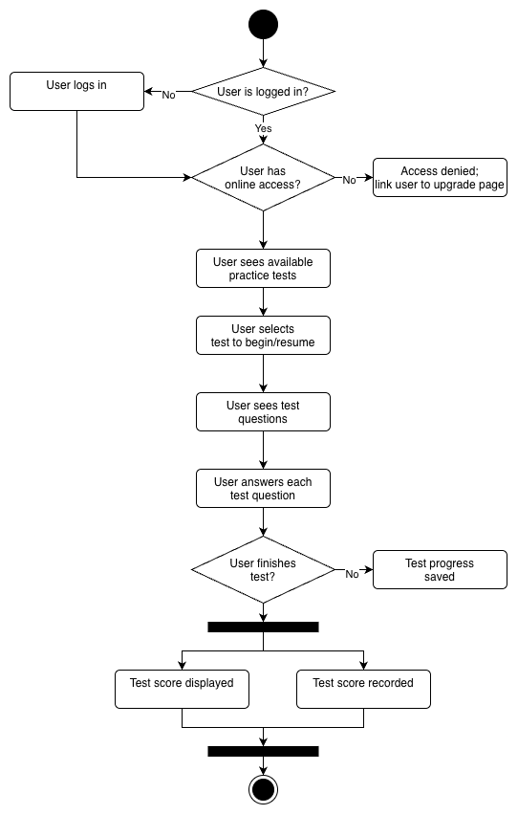
Figure 5. UML activity diagram for taking a practice test.

UML Sequence Diagram
[You were asked to create a sequence diagram based on one of the use cases you chose. Please insert your sequence diagram here. Check to make sure that you included appropriate components and symbols and that your design meets the client’s needs.]

Below is the sequence diagram for the user taking a practice test.
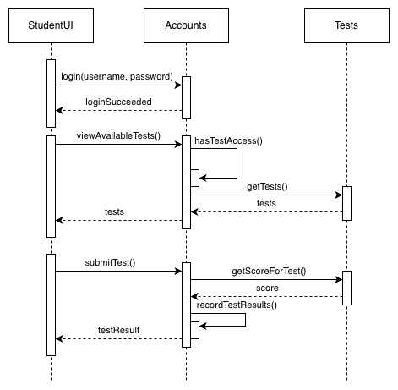
Figure 6. Sequence diagram for taking a practice test.

UML Class Diagram
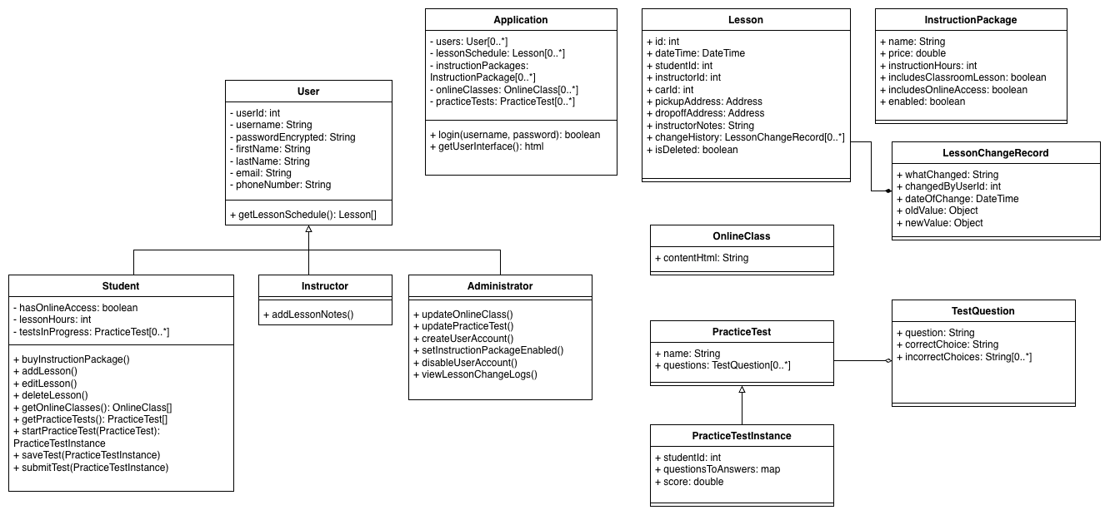
Figure 7. UML class diagram for the DriverPass system.

Technical Requirements
[Based on the diagrams you have created, describe the technical requirements of your system. These requirements should address the required hardware, software, tools, and infrastructure necessary for your system design.]

Hardware:
- Server host system with a minimum of 16 cores, 32 GB RAM, and 1 TB hard drive space (more if the online classes include multimedia content)
- Employee computers to interact with and administer the system. Simple laptops capable of web browsing will suffice.

Software:
- GNU/Linux operating system (Ubuntu Server, Red Hat Enterprise Linux, Debian, or similar)
- Docker containerization engine (latest version).
- The DriverPass application container and its associated docker-compose.yml file, which will install and configure the application and its dependencies such as databases.

Tools:
- SSH software for command-line interaction with the server (e.g., PuTTY for Windows)
- Administration tools for the database(s) used by DriverPass, such as pgAdmin (postgres) or mongosh (MongoDB).

Infrastructure:
- Business-grade Internet service with 99.999% uptime and a minimum of 1 Gbps upload and download speed (more for multimedia content).
- Routers and switches required for connecting the server to the corporate network and the outside world.
- Hardware firewall for network security.

